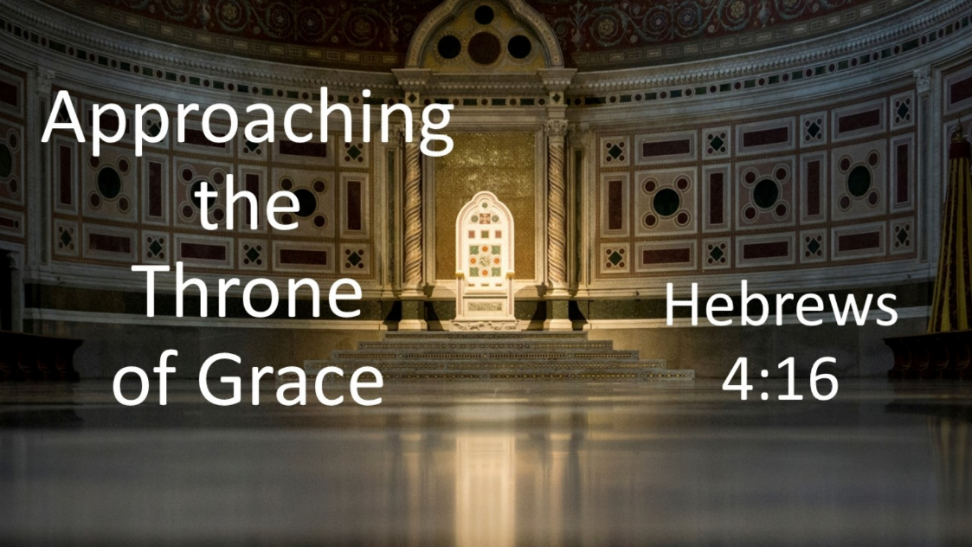
Approaching the Throne of Grace
Hebrews 4:16
November 1, 2026

Let us then approach God’s throne of grace with confidence,
so that we may receive mercy and find grace to help us in our time of need.

Several points of contrast between Esther approaching her king and believers’ opportunity to approach our King…

I. King: Xerxes vs. GOD

- CHARACTER

- POWER & Glory

II. Access: Restricted & RISKY vs. OPEN & free

III. How enter: The SCEPTER vs. The CROSS

IV. Attitude: ALOOF detachment vs. SYPATHETIC understanding

V. Favor: FICKLE vs. UNCHANGING

VI. Provision: LIMITED vs. perfectly FIT to our need

