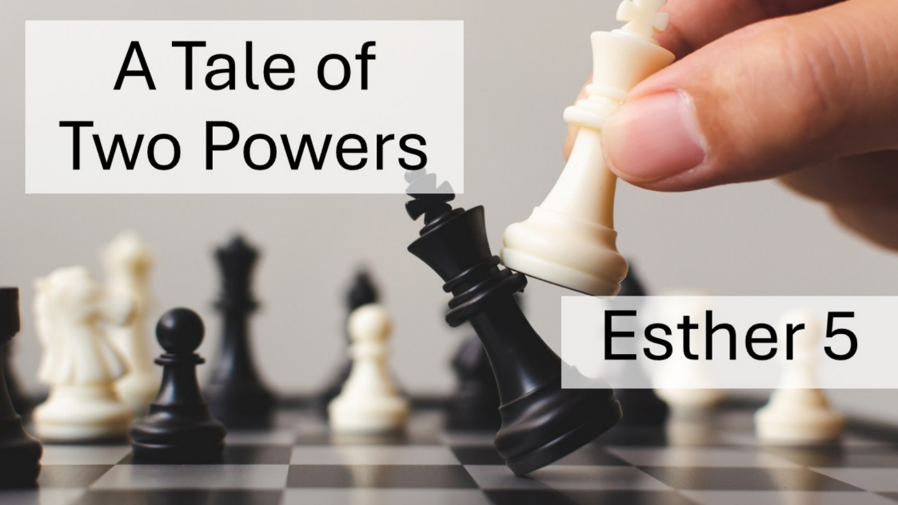
A Tale of Two Powers
Esther 5
October 18, 2026

The direction of your life hinges on the power you choose to serve.

I. We can rest secure in God’s POWER and GRACE when we choose to serve His purposes. (1-8)

- Courageously put FEET to faith.

- Selflessly seek the good of OTHERS.

- Strategically walk in WISDOM & PATIENCE.

II. We will never find lasting SATISFACTION when we choose to serve idols (9-14)

- Beware of FUELING idolatry rather than forsaking it.

- Beware of being convinced of your own SIGNIFICANCE.

- Beware of surrounding yourself with voices that will REINFORCE you in all the wrong ways.

- Beware of DEVALUING anyone in the way of what you want.

