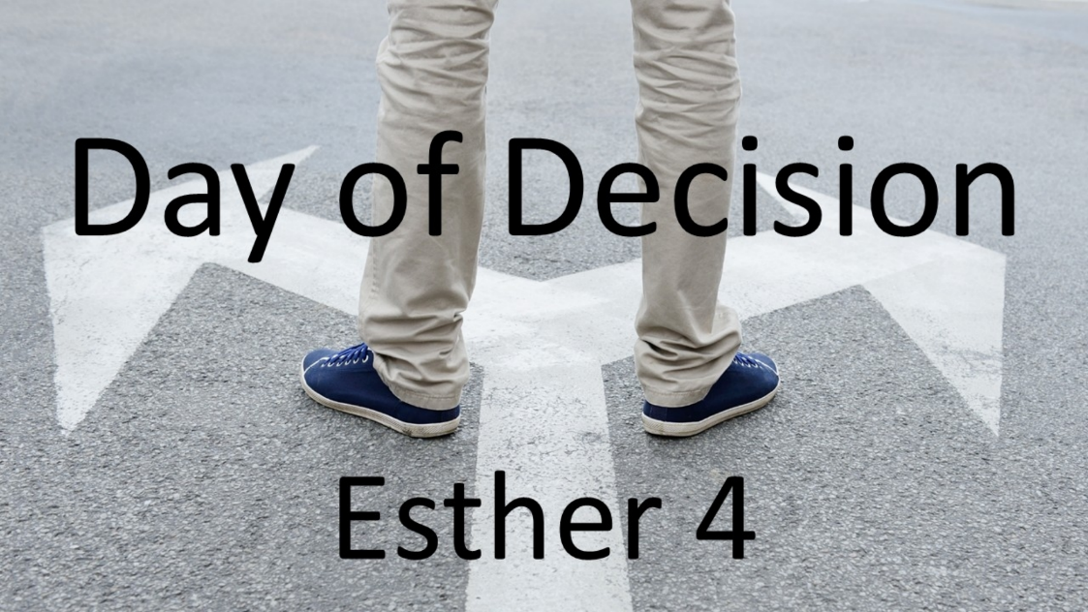
Day of Decision
Esther 4
October 11, 2026

Let your faith in God move you from passive reluctance
to courageous obedience to Him.

- When challenges hit, our response so often is to either INSULATE and IGNORE or turn to human FIXES. (1-8)

- When challenges hit, leverage the POSITIONS and OPPORTUNITIES God supplies for His kingdom. (9-17)

- This requires REJECTING a “someone else will do something” mentality.

- This requires counting the COST.

- This requires actively choosing which KINGDOM you will serve.

- This requires focusing more on what GOD can do than what we can’t.

    - Seek God with FASTING and PRAYER.

    - Trust Christ as our better MEDIATOR.

