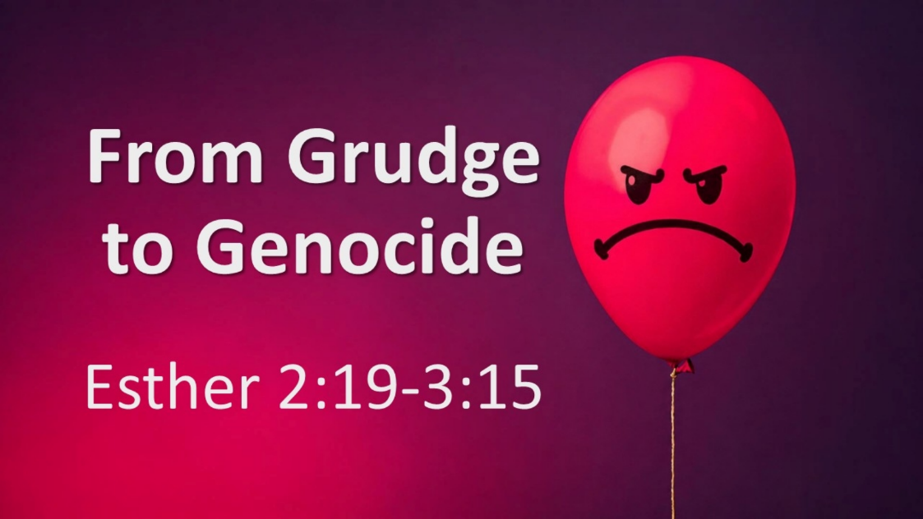
From Grudge to Genocide
Esther 2:19-3:15
September 27, 2026

Even on the darkest days, God reigns.

God reigns even when…

- INJUSTICE & DISAPPOINTMENT happen (2:19-3:1)

- The wicked PROSPER (3:1-6)

- The power of this world seeks to DESTROY us (7-15)

