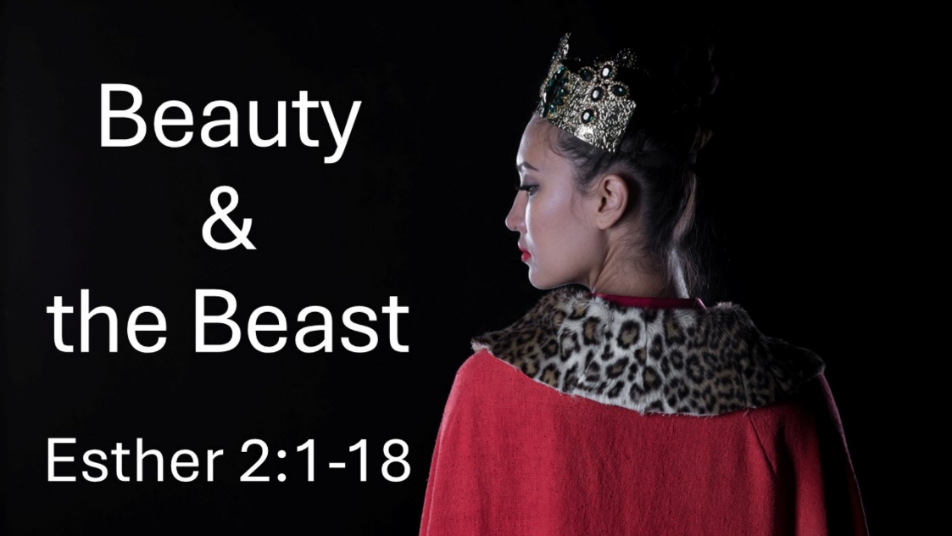
Beauty and the Beast
Esther 2:1-18
September 20, 2026

Even in the darkness and fallenness of this world,
God is graciously and sovereignly at work.

God is at work even in…

I. The BROKEN situations created by the abuse and self-indulgence of those in
power. (1-4)

II. The FAILURES and COMPROMISES of His people. (5-11)

III. The SHAME and SUPERFICIALITY of the games this world plays. (12-18)

Jesus connections not to miss:

1. Xerxes exercised authority for his own GRATIFICATION… but Jesus does so for our GOOD

2. Xerxes sought a beautiful and pure BRIDE… but Jesus MAKES us into one.

3. Xerxes left the women he used with SHAME… but Jesus came to take our shame AWAY.

4. Mordecai and Esther COMPROMISED in different ways… but Jesus NEVER did, even when He was offered the world.

