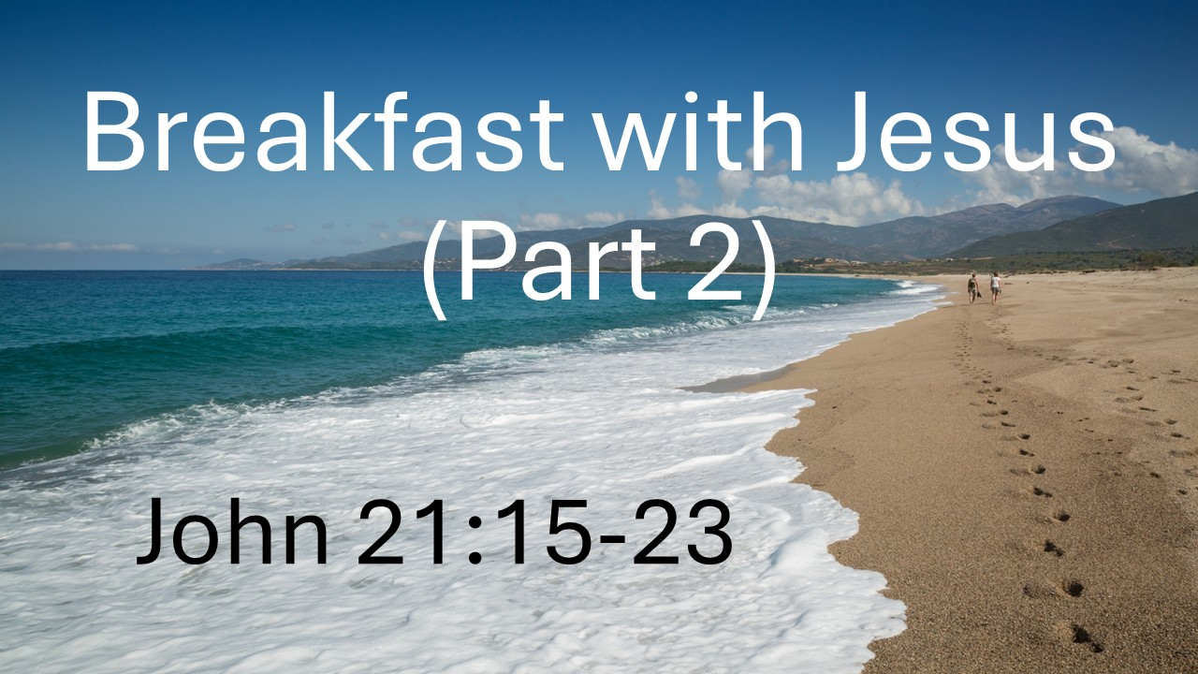
Breakfast with Jesus (Part 2)
John 21:15-23
August 9, 2026

The resurrection of Jesus meets real life when we believe, love, and follow Him.

Following the resurrected Jesus means…

I. Our highest priority and central motivation must be LOVE for Christ. (15-17)

A. Who we love matters MORE than what we do.

B. Who we love will directly IMPACT what we do.

II. Our commitment will not be to our own COMFORT but to the CROSS of Christ
(18-19)

A. Redefining “God loves you and has a WONDERFUL plan for your life.”

B. Redefining the reason for suffering – beyond punishment to a means
of GLORIFYING God.

III. Our calling frees us from getting caught up in the COMPARISON game. (20-23)

A. Our callings are wonderfully DIFFERENT and DIVERSE.

B. Our callings are helpfully simple: FOLLOW Jesus.

