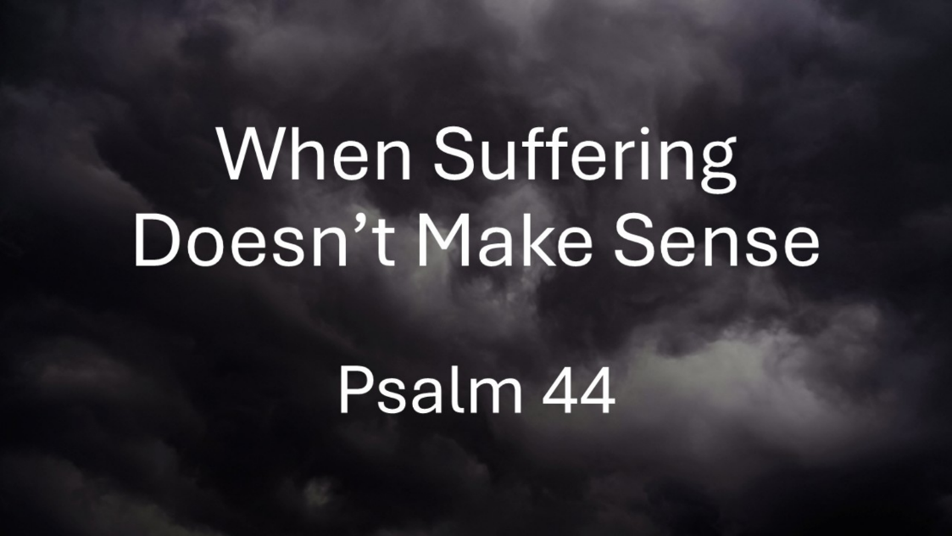
When Suffering Doesn’t Make Sense
Psalm 44
August 30, 2026

In the midst of suffering that doesn’t make sense we need faith that
remembers, laments, protests, & persists.

- Faith that REMEMBERS God’s faithfulness in the past (1-8)

  - Remembering REORIENTS us to the bigger story

  - Remembering reaffirms our IDENTITY

  - Remembering ignites HOPE in our prayers

II. Faith that LAMENTS present suffering with raw honesty to God (9-16)

III. Faith that brings our protest of INJUSTICE to the throne of God (17-22)

IV. Faith that stubbornly PERSISTS in hoping in God (23-26)

  - Persists in CRYING OUT to God for His deliverance

  - Persists in CLINGING to who God is

