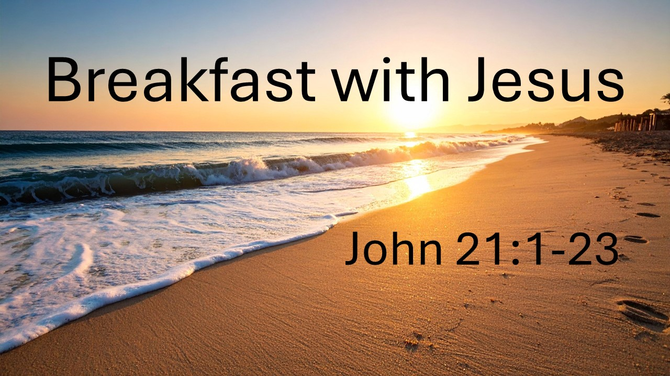
Breakfast with Jesus (Part 1)
John 21:1-17
August 2, 2026

The resurrection of Jesus meets real life when we believe, love, and follow Him.

Following the resurrected Jesus means…

I. Our confidence is not in our own STRENGTH but in the SOVEREIGNTY of Christ.
(1-14)

II. Our standing is not based on our PERFORMANCE but on the GRACE of Christ.
(15-17)

A. Grace knows our NAME and our STORY.

B. Grace doesn’t ignore our FAILURES but meets us in them.

C. Grace is always greater than our greatest SIN.

D. Grace invites us to REST in the gospel instead of trying to PROVE ourselves.

E. Grace restores us to MISSION.

