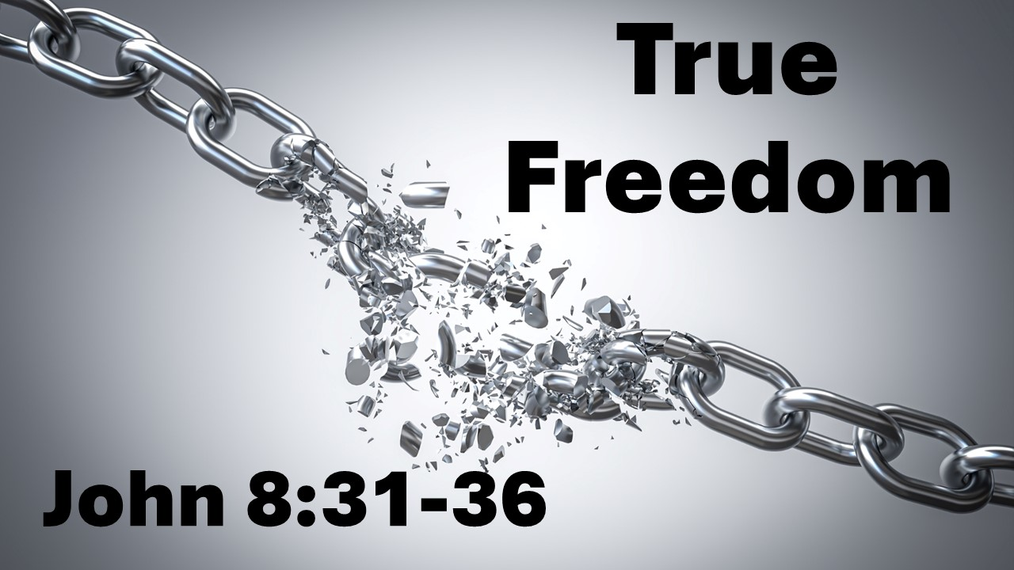
True Freedom
John 8:31-36
July 4, 2026

True freedom comes from knowing Christ through genuine faith & abiding in His Word.

I. Partial or imitation types of true freedom

- Freedom from unjust OPPRESSION.

- Freedom of infinite CHOICE.

- Freedom to do what I WANT.

II. In Christ, we find true freedom from…

- Freedom from the EMPTY way of life found in self-absorption.

- Freedom from IGNORANCE.

- Freedom from trying to be enough through PERFORMANCE or PEOPLE-PLEASING.

- Freedom from the BONDAGE of sin and death.

III. In Christ, we find the true purpose of freedom.

A. Set free to serve a new, better MASTER.

B. Set free to serve others in LOVE.

