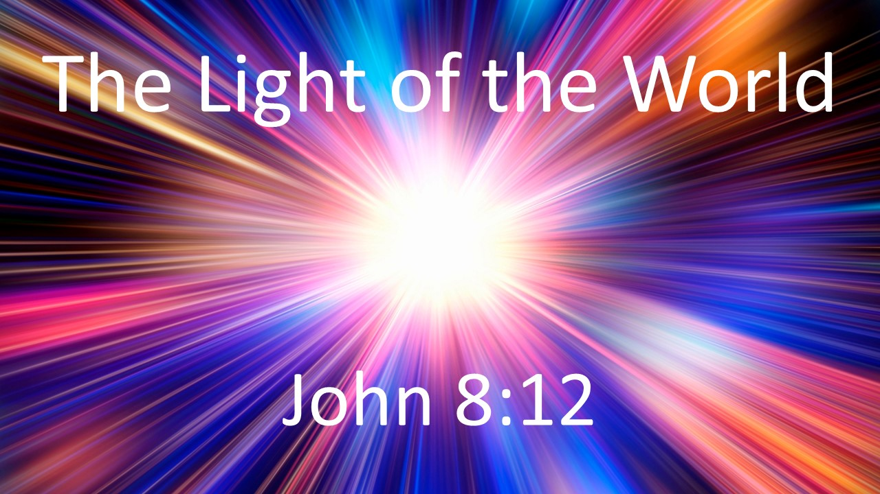
John 8:12
The Light of the World
July 19, 2026

Jesus, the Light of the world, has come into the darkness
to bring us into God’s marvelous light.

I. In our deadness, this Light brings new LIFE.

II. In our blindness, this Light shows the TRUTH.

III. In our enslavement, this Light sets us FREE.

