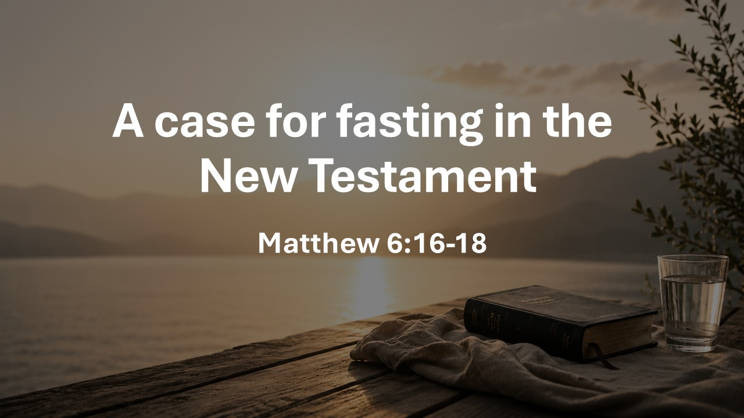
A Case for Fasting in the New Testament
Matthew 6:16-18
June 7, 2026

Jesus assumes that believers WILL FAST

Verse 16: When, not IF

When fasting, avoid

GLOOMY faces

OUTWARD suffering

VISIBLE religion

Fasting is not a REQUIRED sacrament

Matthew 9:14-17

Why should we fast now?

When should we fast?

How should we fast?

Fasting DOES NOT earn us salvation

Fasting pursues intimacy with God, expresses dependence, fights distractions, and cultivates hunger for Christ

What is one appetite you can fast from this week to seek Christ more fully?
_____________________________________________________

Fasting is a situationally birthed, psychosomatically sensed, prompt from the soul to seek direction, correction, or comfort from God through prayer-soaked abstention, as we await the return of our King.​
-David Kakish

