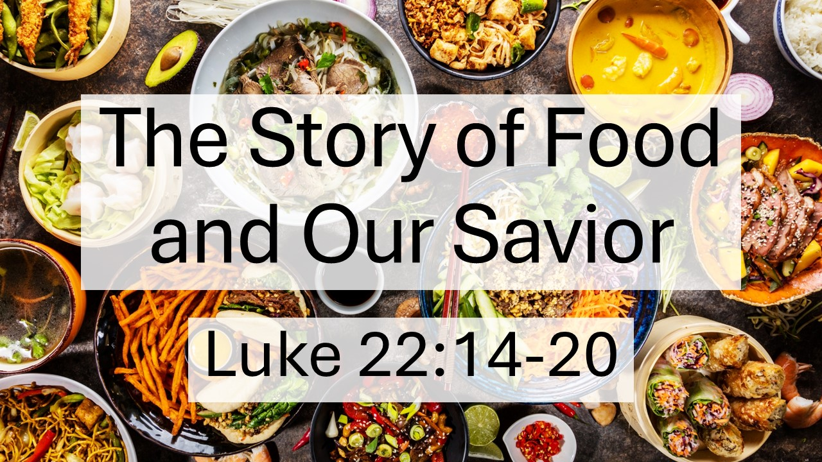
Luke 22:14-20
The Story of Food and Our Savior
June 28, 2026

God created & redeemed us to enjoy a feast of fellowship with Him forever.

I. Biblical lessons we are meant to learn through food
A. DEPENDENCE

B. DOMINION

C. FELLOWSHIP

D. GRATITUDE & WORSHIP

II. Rebellion through food and the distortions that followed

- We use food for CONTROL instead of looking to God’s GREATNESS.

- We use food for IMAGE instead of looking to God’s GLORY.

C. We use food for REFUGE instead of looking to God’s GOODNESS.

D. We use food for IDENTITY instead of looking to God’s GRACE.

III. Redemption in Jesus, pictured in a multi-faceted meal

- Jesus, the new ADAM and better ISRAEL who succeeded where we failed with food

- Jesus, the PASSOVER Lamb, given for the redemption of His people

- Jesus, the WAY MAKER who gracious invites sinners into fellowship

- Jesus, the BREAD of heaven, given for us

- Jesus, the ESTABLISHER of a new covenant by His blood

F. Jesus, the HOST of the messianic feast to come

