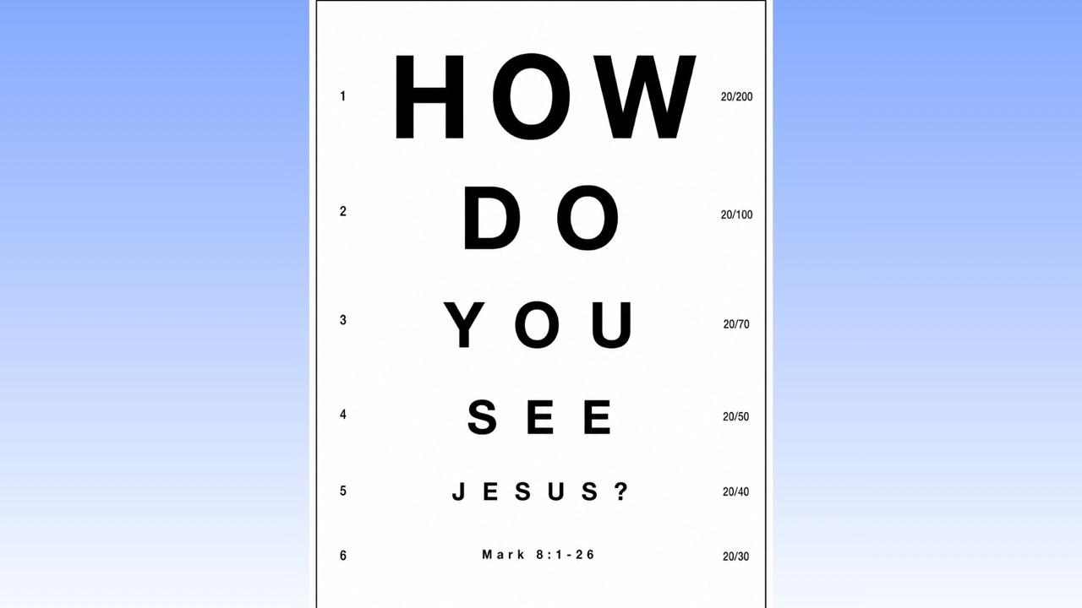
How Do You See Jesus?
Mark 8:1-26
June 14, 2026

Our only hope of seeing Jesus rightly is for Him to open our eyes.

I. Jesus wants us to see that He has come to provide salvation for ALL who believe in Him. (1-10)

II. Faulty solution for seeing Jesus #1 – The blindness of endlessly demanding more EVIDENCE. (11-13)

III. Faulty solution for seeing Jesus #2 – The shortsightedness of FAMILIARITY.
(14-21)

IV. The only real solution for seeing Jesus – Jesus OPENING our eyes (22-26)

