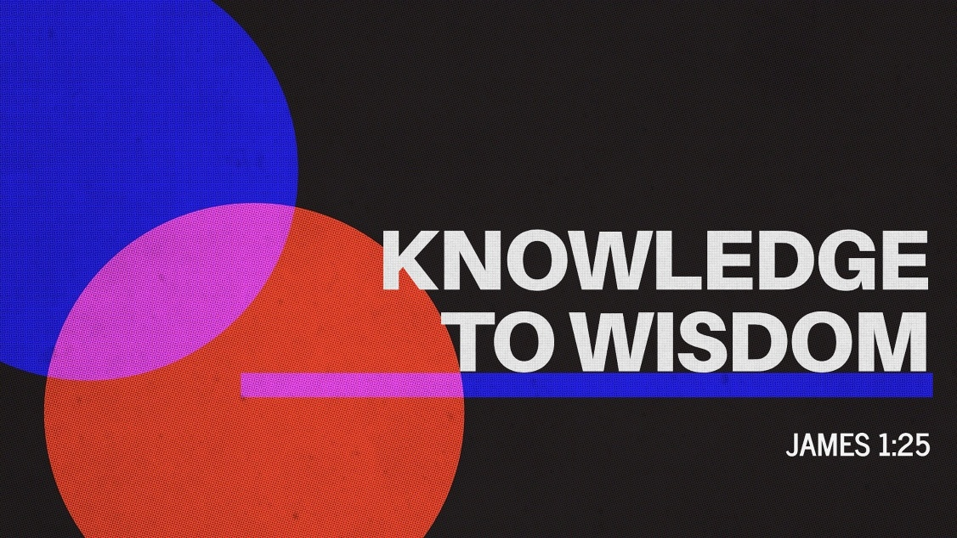
Knowledge to Wisdom
James 1:25
May 24, 2026

James 1:25

Psalm 27:7-8

Psalm 27:11

Psalm 37:5-6

