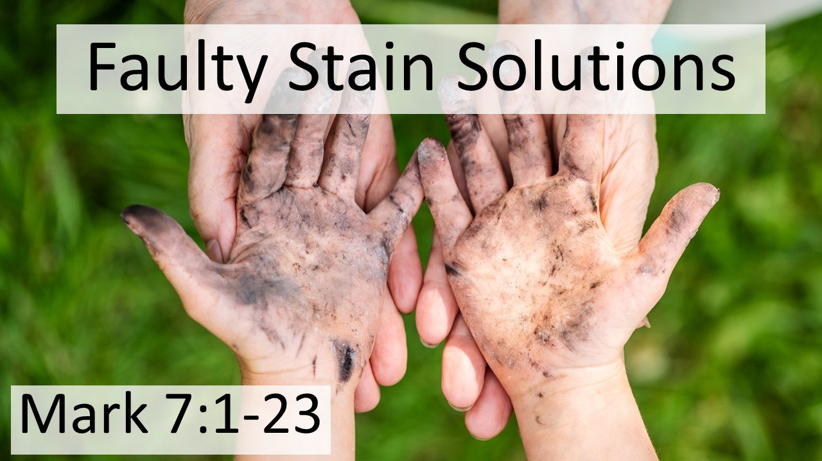
Faulty Stain Solutions
Mark 7:1-23
May 17, 2026

Our stains go far deeper than what we do to the heart of who we are.

Three ways we turn to legalistic solutions for our stains…

I. We have RULES that appear to honor God which really only serve ourselves. (1-8)

II. We manipulate God’s Word by manufacturing LOOPHOLES. (9-13)

III. We think outside-in change can FIX what our real problem is. (14-23)

