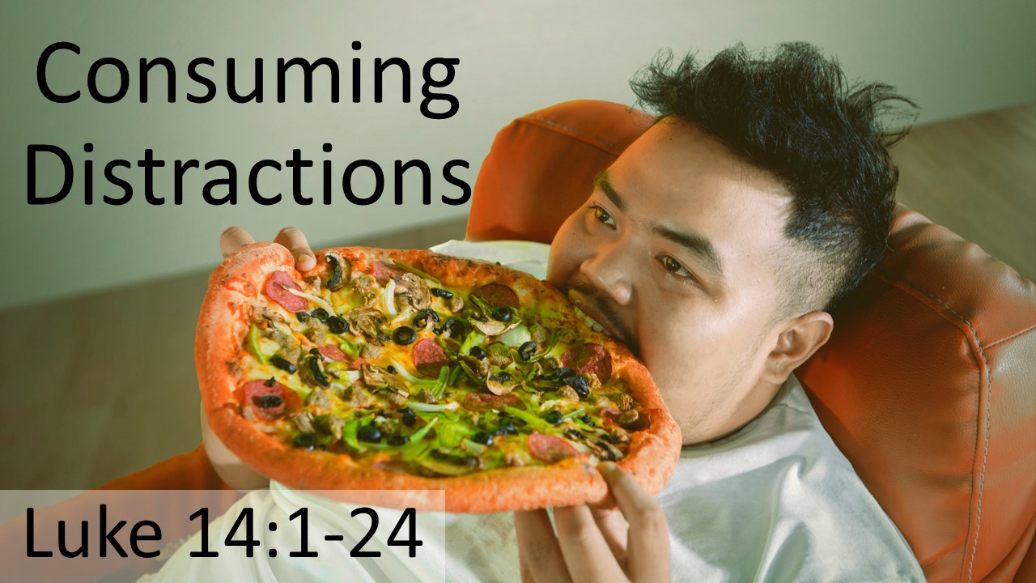
Consuming Distractions
Luke 14:1-24
May 10, 2026

Beware of those things that consume and distract you from what truly matters.

Four challenges to things that produce a dangerous unquenchable thirst in us…

I. To the RELIGIOUS – Do you feel the bondage your LEGALISM produces? (1-6)

II. To the PROUD – Do you see how your efforts to be something are leading NOWHERE? (7-11)

III. To the WEALTHY – How much of your GENEROSITY is really self-love? (12-14)

IV. To the PRESUMING – Are the cares of this world prompting you to make a dangerous ASSUMPTION? (15-24)

