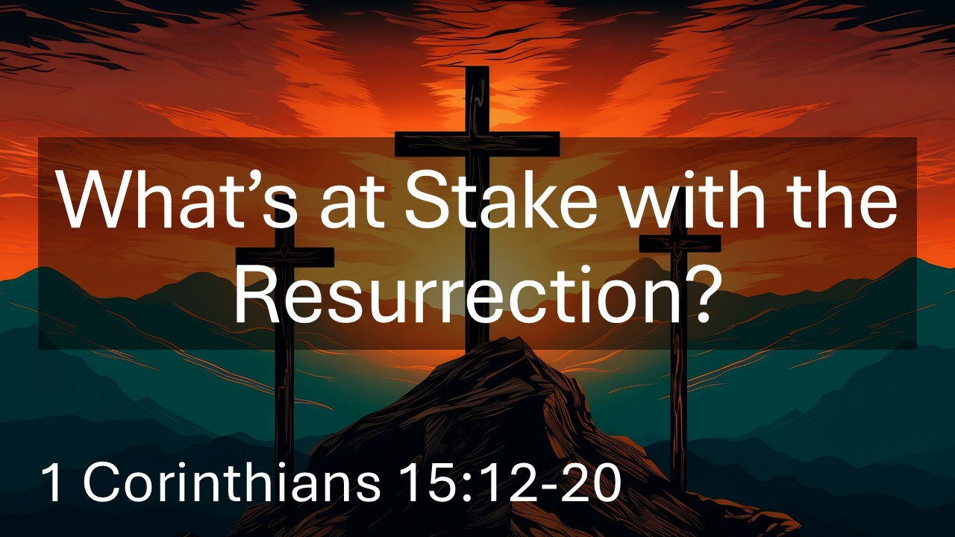
What’s at Stake with the Resurrection?
1 Corinthians 15:12-20
April 5, 2026

Everything hinges on whether Jesus rose from the dead or not.

If Jesus has not risen from the dead…

I. The Christian message and faith would be WORTHLESS.

II. We would still be in our SINS.

III. We would be holding onto false HOPE.

IV. We would be WASTING our lives.

…BUT Christ HAS been raised!

