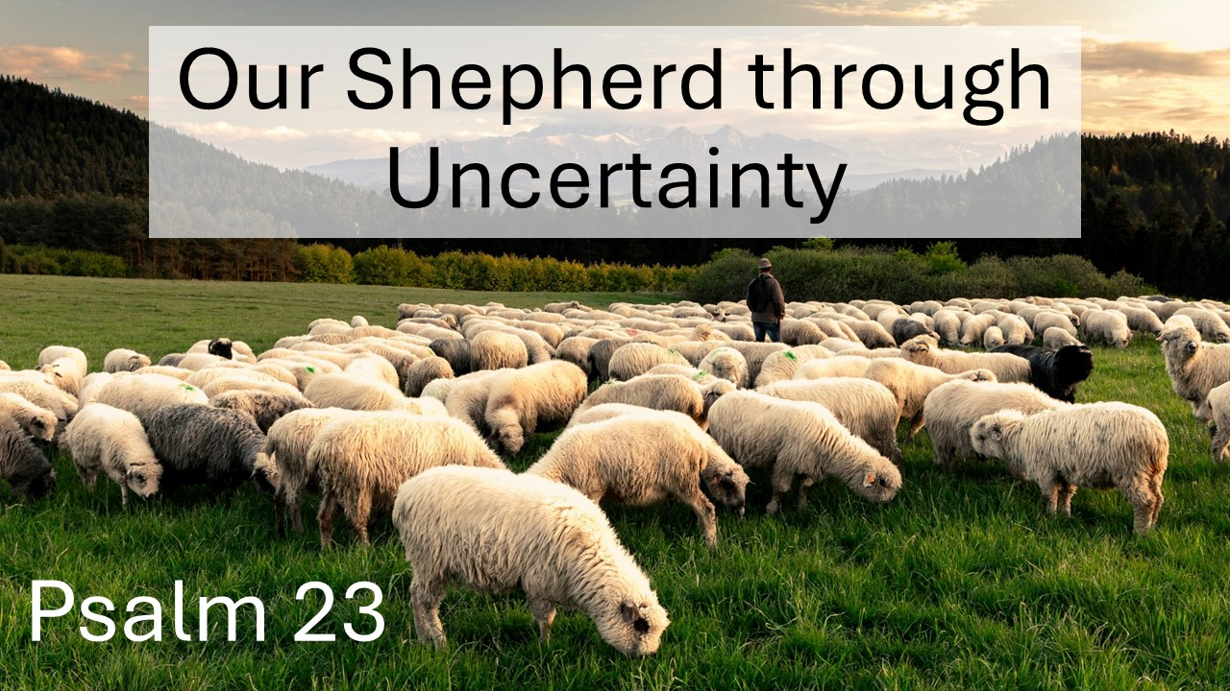
Our Shepherd through Uncertainty
Psalm 23
March 8, 2026

Because the Lord is our Shepherd, we have everything we need.

I. SHEPHERD & sheep (1)

In Him we find…

II. Abundant PROVISION (2-3)

III. SECURITY & Peace (4-5)

IV. BLESSINGS that will never end (6)

