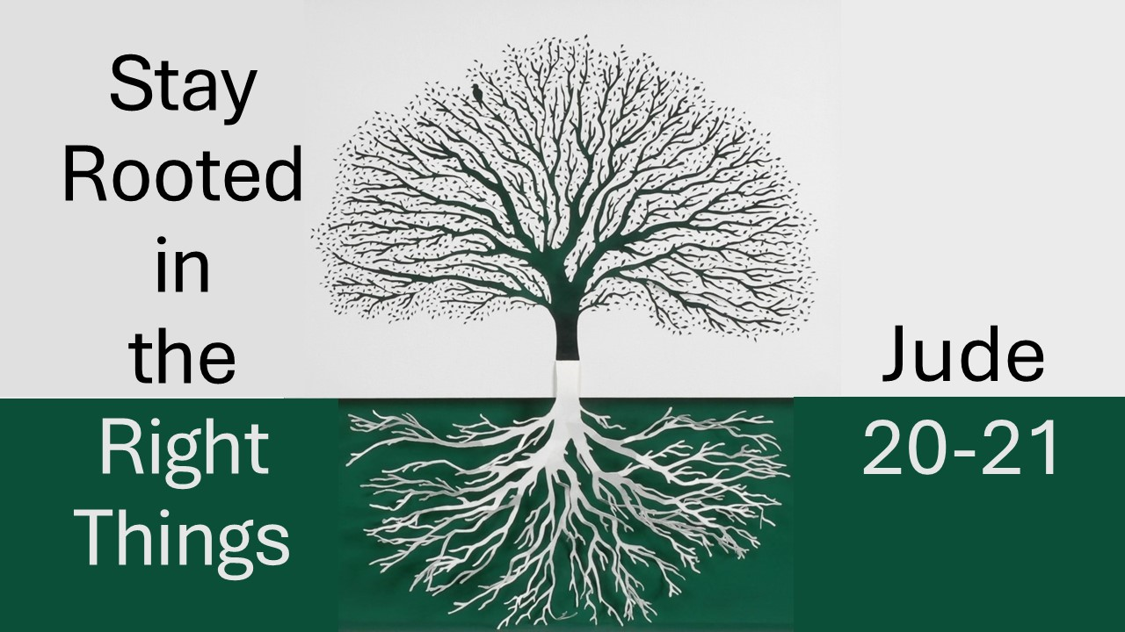
Stay Rooted in the Right Things
Jude 20-21
March 15, 2026

Hold fast to what makes you a community of Christ.

I. KEEP yourselves in the love of God (21a)

II. By BUILDING yourselves up in your most holy faith (20a)

III. By PRAYING in the Holy Spirit (20b)

IV. By WAITING with hope, anticipating heaven with Christ (21b)

