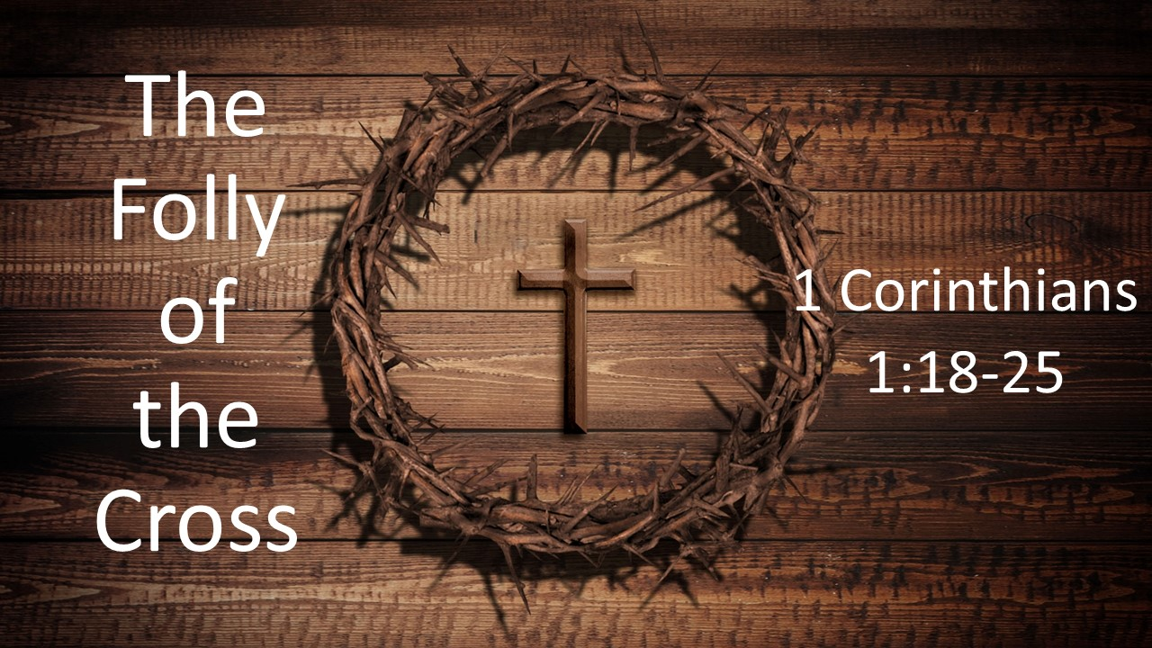
The Folly of the Cross
1 Corinthians 1:18-25
March 1, 2026

The brilliance of God’s wisdom is seen in the “folly” of the cross.

Paul outlines for us five lessons about the cross…

I. There is no MIDDLE ground when it comes to the cross (18)

II. The cross turns worldly wisdom on its HEAD (19-20)

III. The cross did what all our wisdom could NEVER do (21)

IV. The cross defies human EXPECTATIONS (22-23)

V. The cross supremely shows the WISDOM and POWER of God (24-25)

So what?

1. You’ll NEVER be saved by your own power and wisdom ONLY by the true power and wisdom of the cross.

2. God is GOD and we are not.

3. God’s way is completely UPSIDE DOWN compared the world’s.

