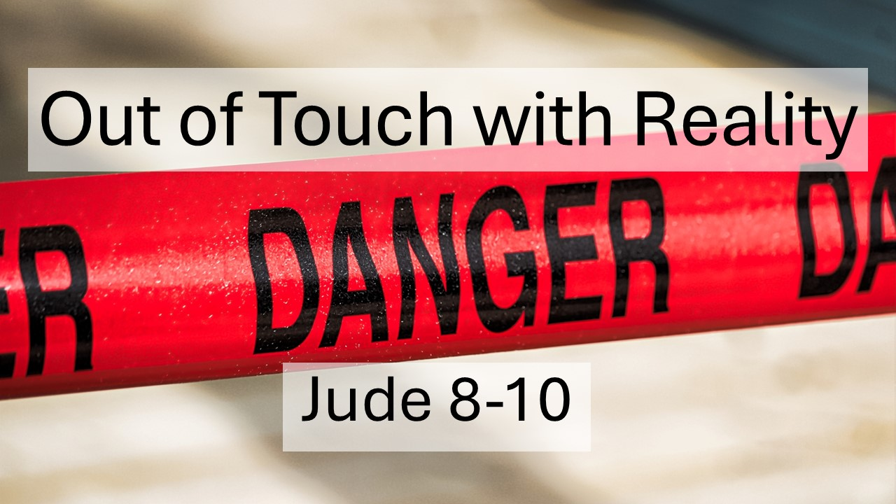
Out of Touch with Reality
Jude 8-10
February 8, 2026

Beware the sins of rebellion, pride, and ignorance
that make big boasts but bring certain judgment.

I. Guard against the sins of REBELLION. (8)

A. Don’t become DEFILED.

B. Don’t become DEFIANT.

C. Don’t become DISRESPECTFUL.

II. Guard against the sins of PRIDE. (9)

A. Know your LIMITS.

B. Recognize your place under God’s AUTHORITY.

III. Guard against the sins of IGNORANCE. (10)

A. Watch your WORDS.

B. Watch what DRIVES you.

