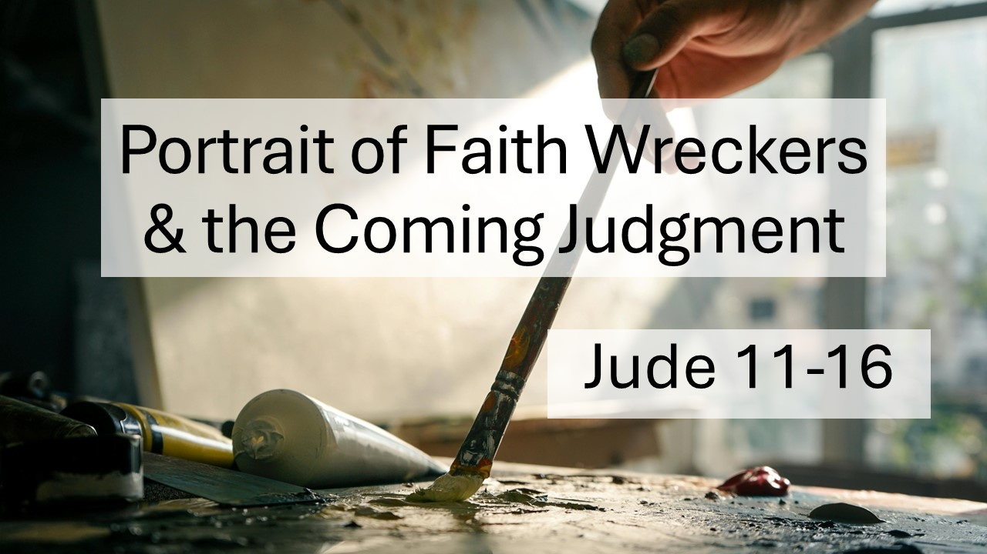
Portrait of Faith Wreckers and the Coming Judgment
Jude 11-16
February 15, 2026

Beware of following those who would lead you away from God
– their judgment is coming!

I. False leaders are DANGEROUS – beware of those who fit the DESCRIPTION! (11-13, 16)

A. Watch in whose FOOTSTEPS they walk. (11)

- The DEFIANCE of Cain

- The CORRUPTION of Balaam

- The REBELLION of Korah

B. Observe their EFFECT on others. (12-13)

- Hidden reefs who leave you SHIPWRECKED

- Self-serving shepherds who leave you EXPLOITED

- Waterless clouds who leave you DISAPPOINTED
- Fruitless trees who leave you BARREN

- Wild waves who leave you FILTHY

- Wandering stars who leave you LOST

C. Listen to how they TALK. (16)

- They GRUMBLE and find FAULT

- They follow their own evil DESIRES

- They BOAST and FLATTER

II. God’s judgment is certain – REPENT and BELIEVE in Christ before it’s too late!
(14-15)

- Jesus is COMING

- Jesus will JUDGE all the ungodly for all their ungodliness

C. Jesus alone can SAVE

