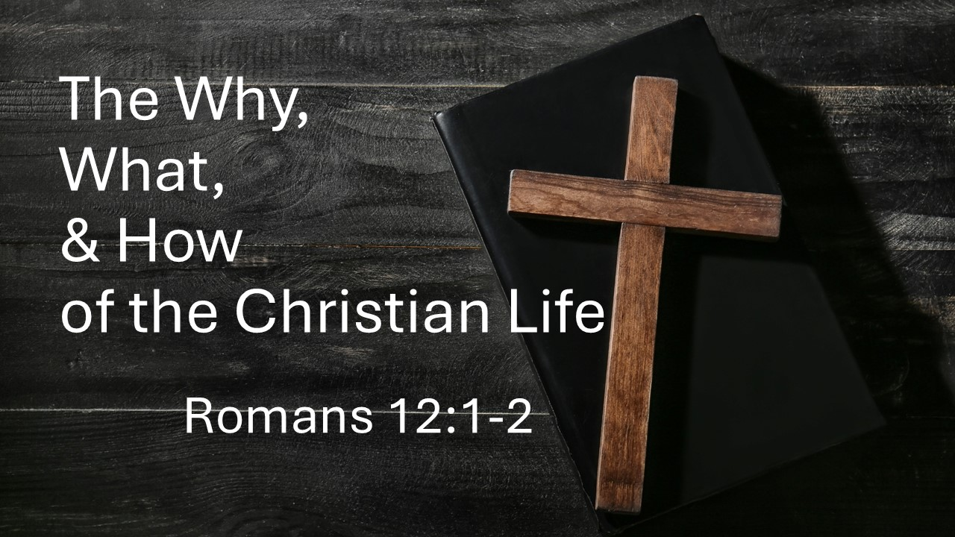
The Why, What, & How of the Christian Life
Romans 12:1-2
January 4, 2026

The Christian life is nothing less than grateful life surrender
and complete transformation.

- The Why – The basis of the Christian life is GRATITUDE for the mercies of God (1a)

- The What – The nature of the Christian life is whole life SACRIFICE (1b)

- The How – The means of the Christian life is an inside out TRANSFORMATION (2)

  - Don’t let this world SQUEEZE you into its mold

  - Be transformed by the RENEWING of your mind

  - Result – Able to KNOW and DO God’s will

