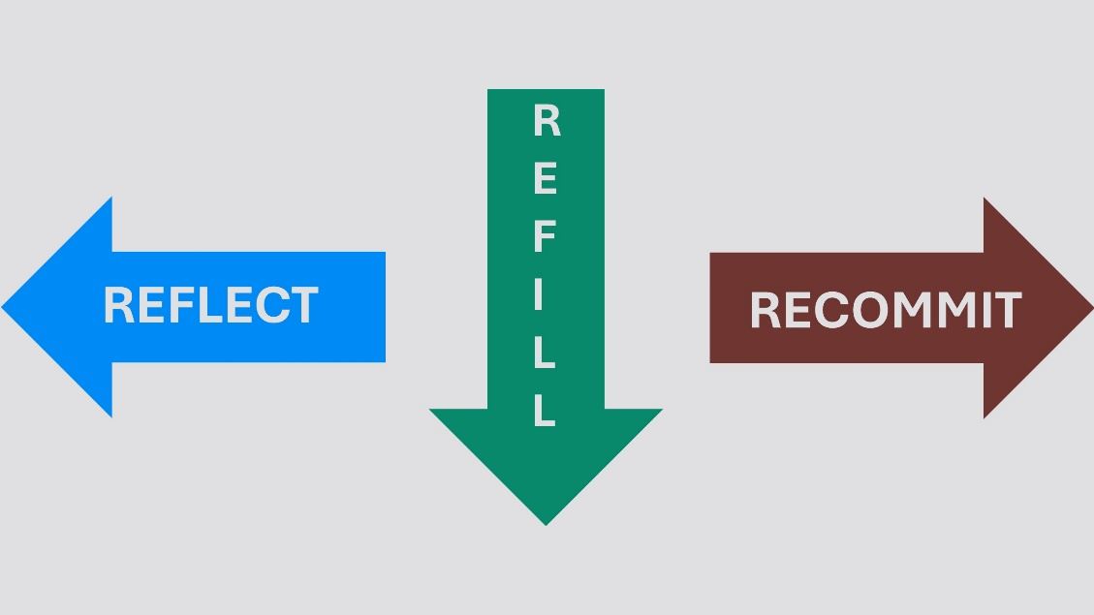
REFLECT, REFILL, RECOMMIT
December 28, 2025
- REFLECT
2 Corinthians 13:5; Psalm 119:5; Romans 12:1-2; Titus 3:5

- Introspection – Prayerful consider your life over the last year, where your ultimate trust is being placed and whether your life aligns with God’s will (ask the Holy Spirit to help you in this – Test me, Lord, and try me, examine my heart and my mind – Psalm 26:2)

- Contemplation – Reflect who God is & praise Him for His attributes such as:
Love, Goodness, Sovereignty, Wisdom, Holiness, Justice, Faithfulness

- Transformation – Ask for God’s help in guarding against being conformed to the world and having your mind, heart, and life transformed by Him. Pray that He would bring the renewal only He can accomplish in you.

- REFILL
Matthew 6:11; Lam. 3:22-24; Isaiah 40:29; Psalm 81:10

Acknowledge Need
“God, here is where I feel empty today…”

Release Control
“God, here is what I’ve been trying to carry on my own…”

Ask for Today’s Bread
“God, I trust You to give me what I need for today—not tomorrow, not next month—just today.”

Closing Prayer
God, we come to You aware of our need.
We stop striving and open our hands.
Fill us today with Your peace, strength, and grace.
Help us trust You one day at a time.
Amen.

- RECOMMIT
Joshua 24:14-15; 1 Corinthians 4:1-2; James 1:5-6

- Deliberate Resolve – Ask God to reveal where your heart has drifted and pride has entered. Pray for help resetting priorities.

- Faithful Stewardship – Pray for help with your struggles and lift your burdens to God. Pray for humility when you encounter difficulties.

- God’s Wisdom – Reflect on the areas where you’ve tried to do things on your own and ask God to provide guidance. Pray for help letting go of the things you hold onto, afraid to lose control.

