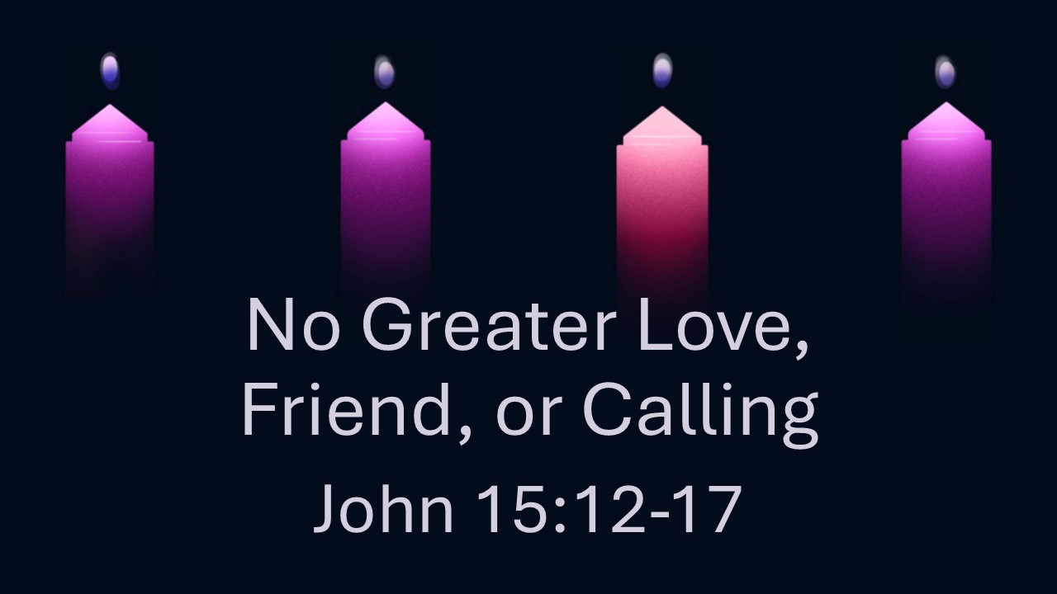
No Greater Love, Friend, or Calling
John 15:12-17
December 21, 2025

In Jesus we find the greatest love, friend, and calling.

- The Greatest Love (12-13, 17)

    - The Command – LOVE each other

    - The Standard – SACRIFICIALLY loving others like Jesus

- The Greatest Friend (14-15)

    - The evidence of friendship with Jesus – OBEDIENCE to His commands

    - The privilege of friendship with Jesus – brought near as INFORMED friends

- The Greatest Calling (16-17)

    - We have been CHOSEN…

    - …to bear fruit that will LAST…

    - …through PRAYERFUL dependence.

