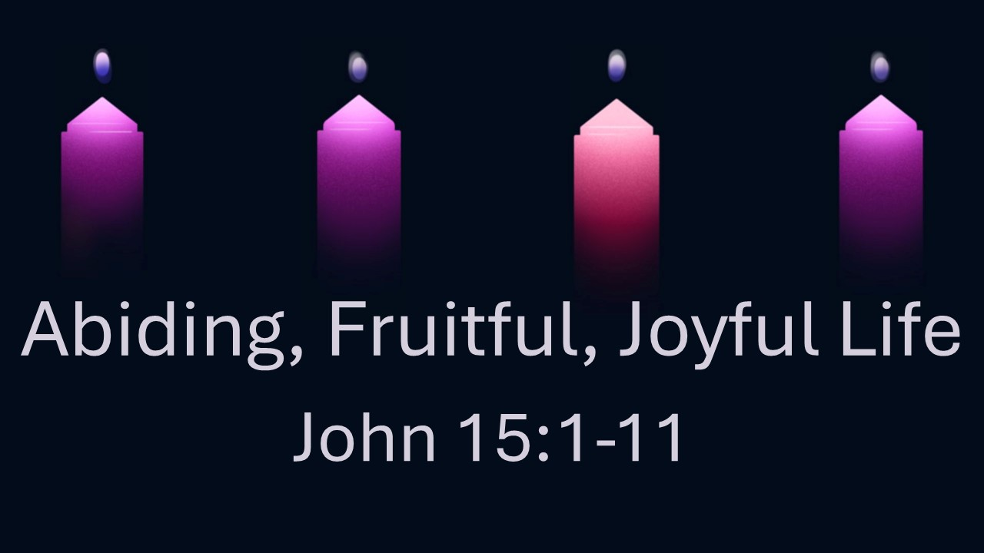
Abiding, Fruitful, Joyful Life
John 15:1-11
December 14, 2025

Abundantly fruitful and joyful life is only found through abiding in Jesus.

- Jesus is the TRUE VINE – 1a

- The Father is the GARDENER – 1b

    - He TAKES AWAY fruitless branches – 2a, 6

    - He PRUNES fruitful branches – 2b

- We are just BRANCHES

    - Our IDENTITY and PURPOSE are found in Him. – 3-5

    - Our central, repeated command: Keep ABIDING in the Vine!

    - What happens when we abide in Him?

      - Abundant FRUITFULNESS – 5

      - Effective PRAYER – 7

      - GLORY to God – 8

      - LOVE and OBEDIENCE – 9-10

      - Fullness of JOY – 11

