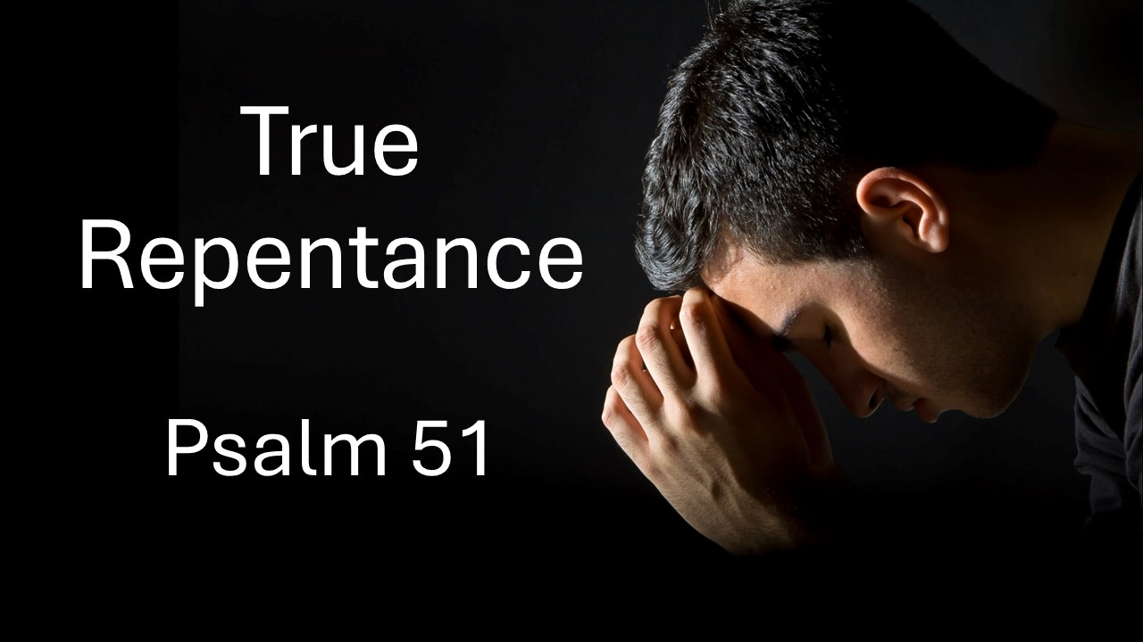
True Repentance
Psalm 51
November 9, 2025

True repentance frees us from sin and propels us toward spiritual renewal.

True repentance…

- Turns to God for full FORGIVENESS (1-2)

- Owns the weighty reality of my SINFULNESS (3-6)

- CRAVES complete spiritual renewal (7-12)

- Gives thanks for God’s grace by SHARING it with others (13-17)

- Longs for COMMUNITY restoration (18-19)

