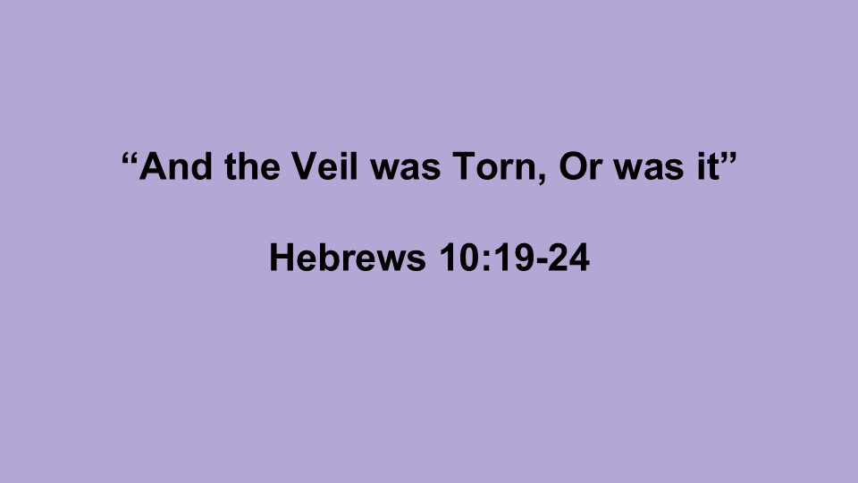
And the Veil Was Torn, Or Was It?
Hebrews 10:19-24
October 5, 2025

Part I: And the Veil was Torn

Genesis Chapter 3

Exodus 26:31

Matthew 27:51

Mark Chapters 11, 12, 13, 14, 15

Part Two: Is the Veil Truly Gone?

Access

Advocacy

My Challenge for You...

