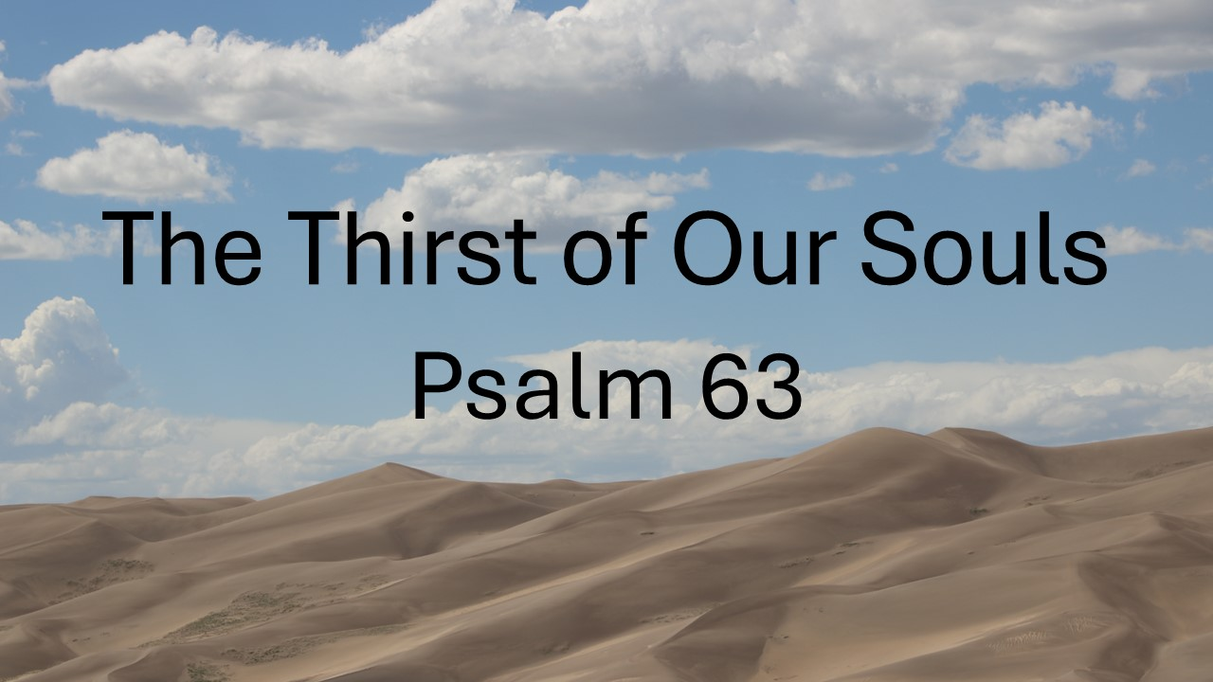
The Thirst of Our Souls
Psalm 63
October 26, 2025

God both stirs and satisfies our deepest longing.

- God: The STIRRER of our deepest longing (1)

- God: The SATISFIER of our deepest longing (2-11)

He is the only One who…

  - Possesses all GLORY & power (2)

  - Showers us with steadfast, unwavering LOVE (3-4)

  - SATISFIES our souls (5)

  - Protects and HELPS us (6-7)

  - Sustains and STRENGTHENS us (8)

  - Gives us the sure HOPE of justice & salvation (9-11)

