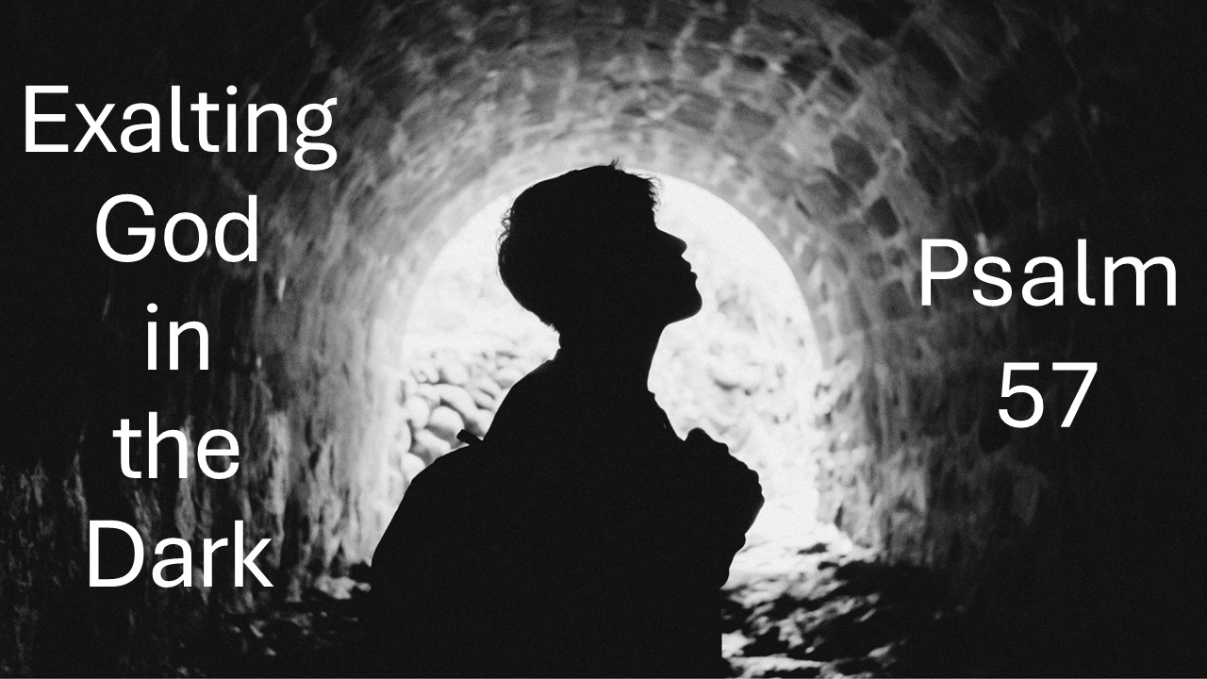
Exalting God in the Dark
Psalm 57
October 19, 2025

Above all, seek to exalt God, even in the midst of the dark.

- Humbly cry out to God for MERCY and focus your HOPE on who He is. (1-3)

- Trust His SALVATION and seek to exalt Him over seeking a way OUT. (4-6)

- Let your contentment in God fuel WORSHIP and making Him KNOWN. (7-11)

