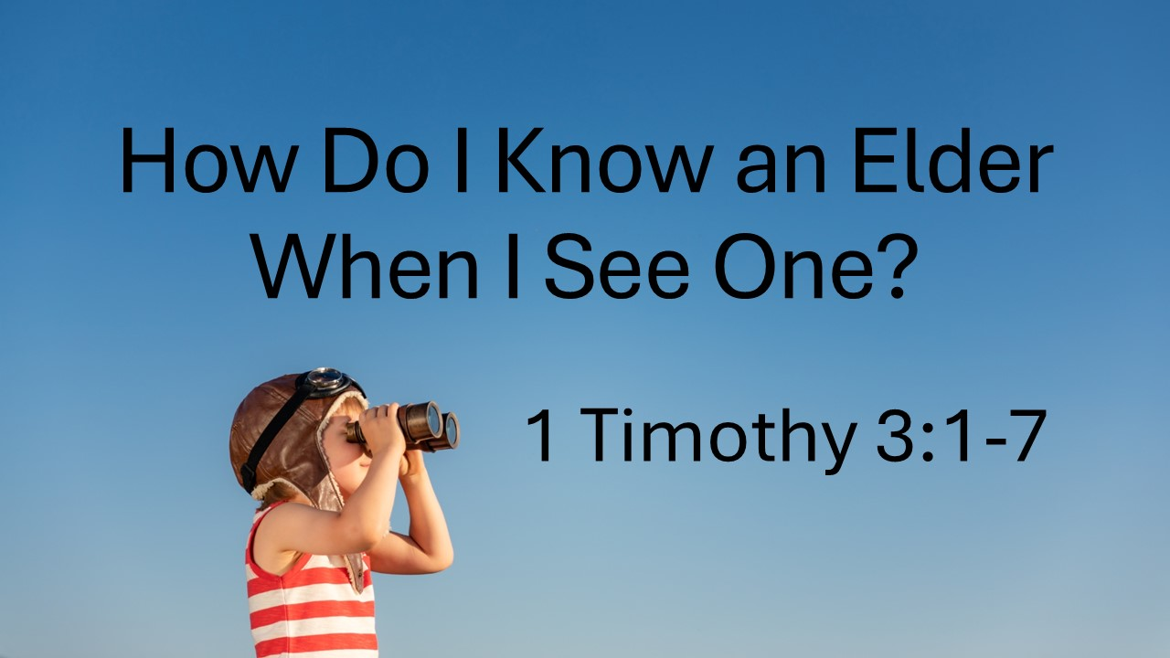
How Do I Know an Elder When I See One?
1 Timothy 3:1-7
August 3, 2025

Qualified elders are essential for a healthy church.

- What are ELDERS?

ELDERS = PASTORS = OVERSEERS

- How does this apply?

    - TRAITS we should look for in elders

    - How we should evaluate and select a PASTOR

    - Who do you let have INFLUENCE in your life?

    - Do you see these traits in YOURSELF?

- What are the qualifications? (1 Timothy 3:1-7; Titus 1:5-9)

- DESIRE for the Task

- Above REPROACH

- A One-WOMAN Man

- SELF-CONTROLLED & Respectable

- HOSPITABLE

- Able to TEACH

- Sober, Gentle, PEACEMAKER

- Not a Lover of MONEY

- Leader at HOME

- MATURE and Humble

- Respected by OUTSIDERS

