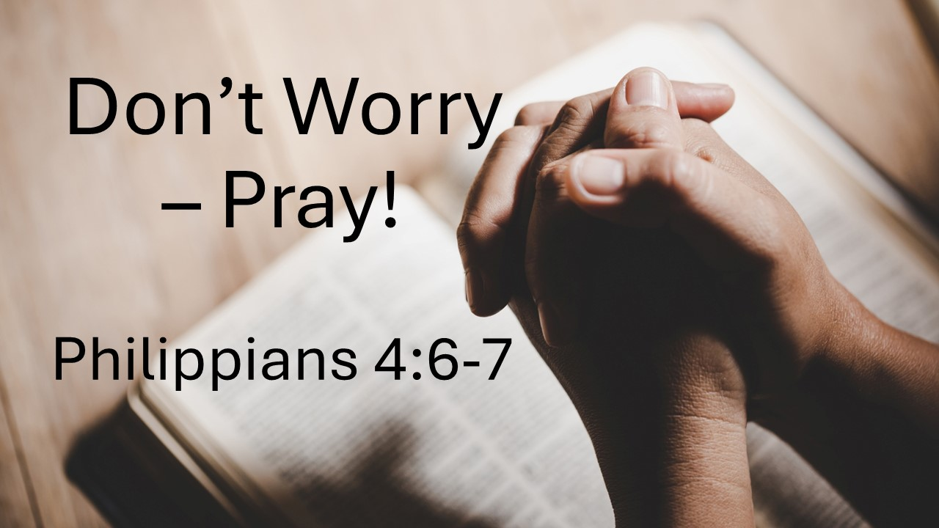

**Don’t Worry - Pray!**

**Philippians 4:6-7**

August 24, 2025

Resolve not to be anxious about anything   
but to learn instead to pray about everything.

1. The Problem of **ANXIETY** – Why is it so bad? (6a, Matt 6:25-34)
   1. God provides for birds and flowers; He will surely provide for **US**.
   2. Worrying is **POINTLESS**.
   3. Worrying is a **PAGAN** practice, not a disciple’s practice.
   4. God knows our **NEEDS** more than we do.
   5. God will **PROVIDE** everything we need when we seek His kingdom and His righteousness.
2. The Prescription of **PRAYER** (6b)
   1. Prayer is the **ANTIDOTE** to anxiety
   2. Remember the **PRIVILEDGE** of prayer
   3. Practice prayer with **THANKFULNESS** about every concern.
3. III. The Promise of **PEACE** (7)
   1. Peace of **GOD**
   2. Peace that transcends all **UNDERSTANDING**
   3. Peace that will **GUARD** your hearts and minds in Christ Jesus.