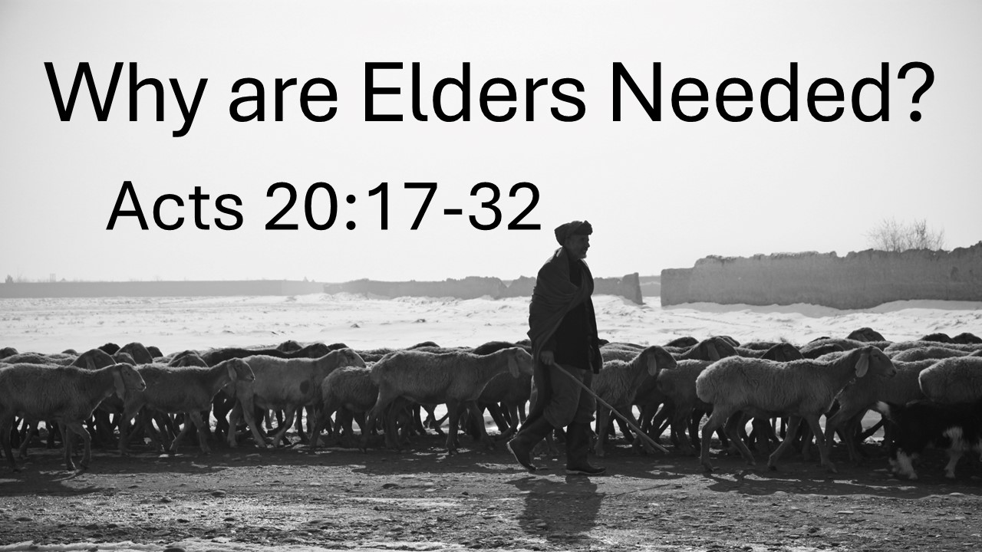
Why are Elders Needed?
Acts 20:17-32
July 6, 2025

God's church needs elders who will care for the flock and protect it from harm.

- What are ELDERS?

ELDERS = PASTORS = OVERSEERS

- The Biblical Legacy of SHEPHERDS

- Paul’s EXAMPLE (17-27)

- He IDENTIFIED with the people (18)

- He served the Lord with HUMILITY & PASSION (19)

- He taught the GOSPEL (20-21)

- He lived by the SPIRIT & treasured JESUS supremely (22-24)

- He served with a clear CONSCIENCE (25-27)

- Paul’s EXHORTATION (28-32)

  - Watch your LIFE (28a)

  - Watch the FLOCK (28b-32)

