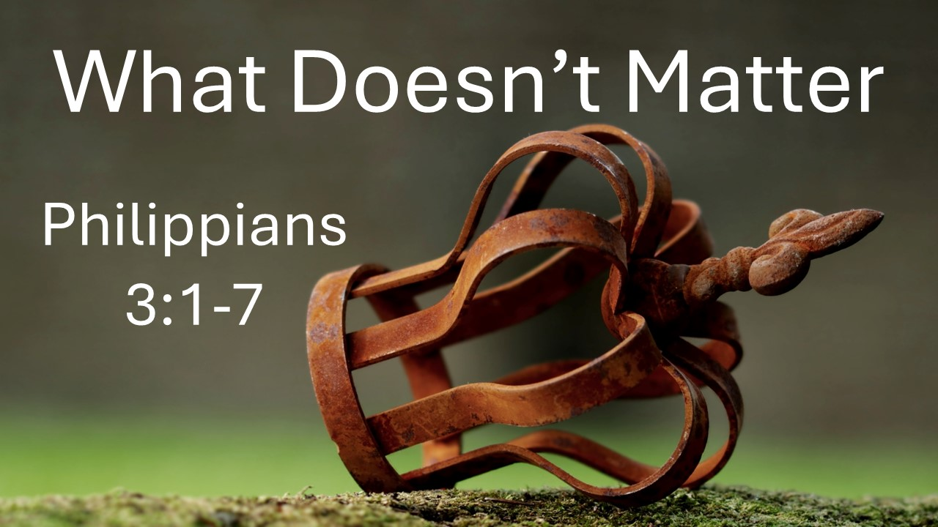
What Doesn’t Matter
Philippians 3:1-7
June 8, 2025

Nothing on our resume can compare with what we already have in Christ.

- REJOICE in the Lord (1)

- Beware of counterfeit Christianity that puts confidence in things in ADDITION to or INSTEAD Christ (2)

- Remember what TRUE Christianity is (3)

  - We worship by the SPIRIT

  - We glory in JESUS

  - We put no confidence in the FLESH

- Consider Paul’s no CONFIDENCE advantages (4-7)

      - RITUAL

      - ANCESTRY

      - RANK

      - Devotion to TRADITION

      - RULE KEEPING

      - ZEAL

      - MORALLY right behavior

